# Functional Description

## User interface:

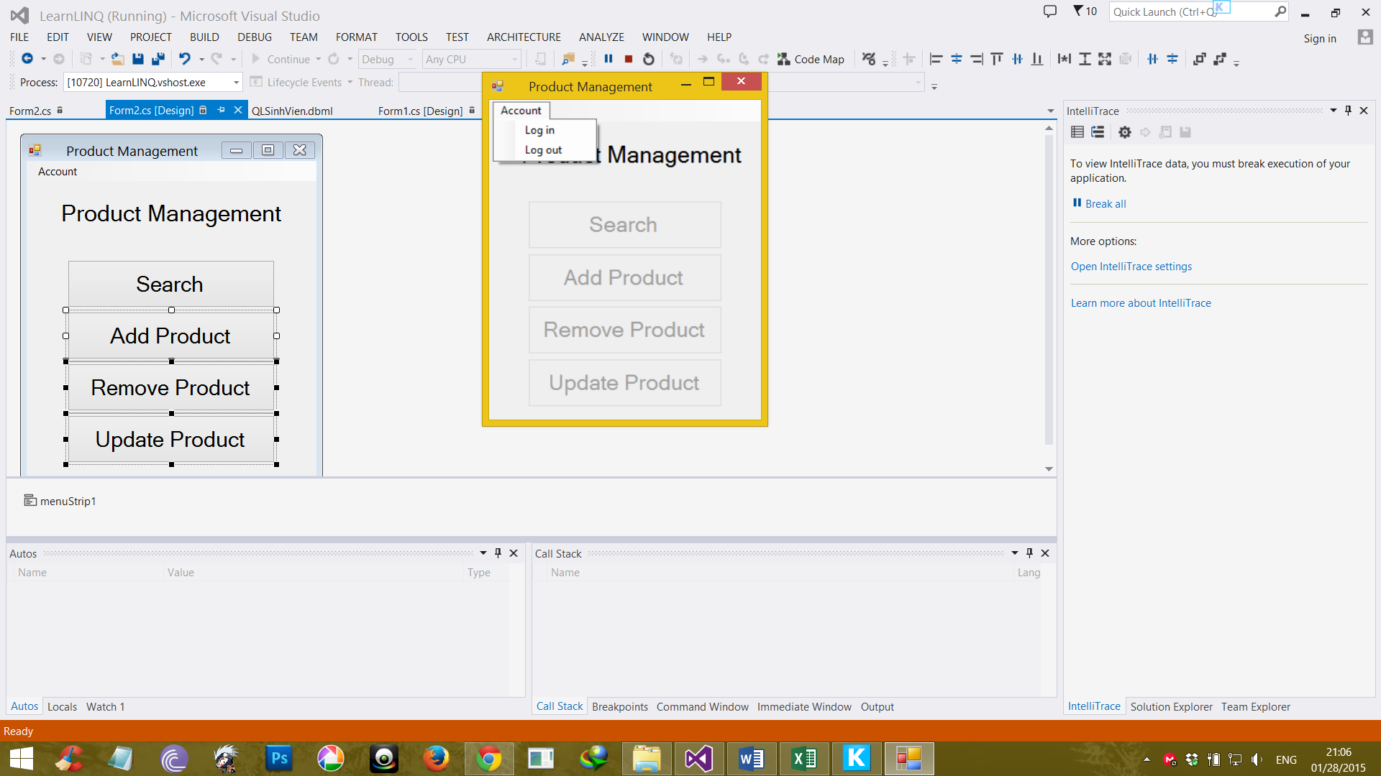

|  |  |  |  |  |  |
| --- | --- | --- | --- | --- | --- |
| **Screen** | Product Management – User interface | | | | |
| **Description** | Display a screen where user can control the product. | | | |
| **Screen Access** | Users run program by click on file **ProductManagement.exe** | | | |
| **Screen Content** | | | | | |
| **Item** | **Type** | **Data** | **Description** | |
| Product Management | Label |  | Name of the software | |
| Account | Menu strip item |  | Name of menu strip | |
| Log in | Menu strip item |  | Open a dialog where user can log into program | |
| Log out | Menu strip item |  | Log out the program. | |
| Search | Button |  | If user click on this button, the “Search” dialog will appear. | |
| Add Product | Button |  | If user click on this button, the “Add Product” dialog will appear. | |
| Remove Product | Button |  | If user click on this button, the “Remove Product” dialog will appear. | |
| Update Product | Button |  | If user click on this button, the “Update Product” dialog will appear. | |
| **Screen Actions** | | | | | |
| **Action Name** | **Description** | | **Success** | **Failure** |
| Log in | Everyone have an account and click on it to enter the system. | | Username of current user will display at the bottom of screen and all buttons will be enabled. | Displays message “Username or password is incorrect.” |
| Log out | Use to exit the system. | | Username of current user at the bottom of screen will be disappeared and all button will be disabled. | Nothing. |
| Search | Search data which existed in database | | “Search” dialog opened | Nothing. |
| Add Product | Add more data. | | “Add Product” dialog opened | Nothing. |
| Remove Product | Remove some of data. | | “Remove Product” dialog opened | Nothing. |
| Update Product | Update some exist fields of data. | | “Update Product” dialog opened | Nothing. |

## Search:

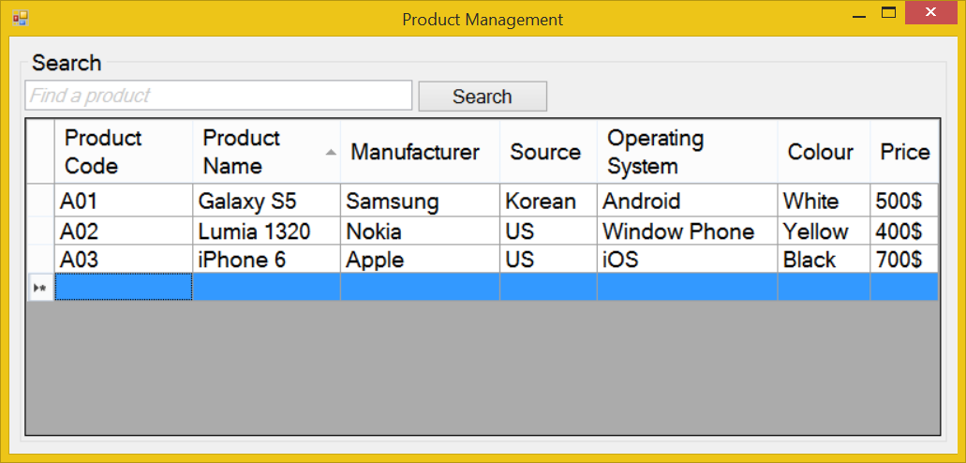

|  |  |  |  |  |  |
| --- | --- | --- | --- | --- | --- |
| **Screen** | Product Management - Search | | | | |
| **Description** | | Display a textbox and a button for “Search” function with the available data displayed in the data grid view below them. | | | |
| **Screen Access** | | Users run program then click on **Search** button | | | |
| **Screen Content** | | | | | |
| **Item** | | **Type** | **Data** | **Description** | |
| Data grid view | | Datagridview | Lookup all fields from PRODUCT table. | * Display all fields about the product when the form loaded: Product code, product name, manufacturer, source, OS, colour, price. * This table is read-only, user cannot edit it. | |
| Find a product | | Text field – String (50) |  | Allow user enter the data to search. | |
| Search | | Button |  | User click on it to search | |
| **Screen Actions** | | | | | |
| **Action Name** | | **Description** | | **Success** | **Failure** |
| Search | | Find a product in the table below. | | Return the result of searching process | Message “Not found”. |

# The shop must ensure that the customers can easily find the exact product they need.

The customer can find their desire product in the catalogue or listen to shop agent’s advices. The catalogue must be updated frequently, accurately, clearly, must be a computer-typing, try to avoid write it down by hand. Inside the catalogue, the shop can classify the products according to manufacturer, pricing… and more.

The shop’s agent check out the customer’s choice, if it available then create an export receipt. If not, the agent must say apologize to the customer and require he (or she) chooses another products.

## Add products

|  |  |
| --- | --- |
| Use Case Name | Add products |
| Use Case ID | ABC001 |
| High Level Requirement Ref | The general information about imported products must be prepared. The manager and the others members who have authority can view the product list. Besides that, they can make the order to import more products. |
| Actor | Shop’s Master, Warehouse Manager, Treasurer, Accountant |
| Description | This use case is used to add more products. |
| Pre-condition | The product is not available in the database. |
| Post-processing | The database has new products. |

### Screen Design

#### Add products – Filter

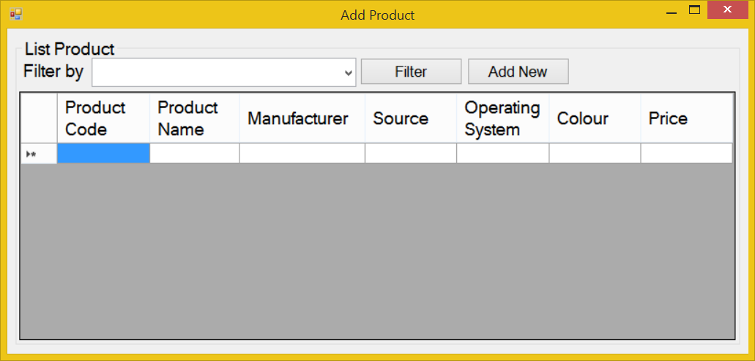

|  |  |  |  |  |  |
| --- | --- | --- | --- | --- | --- |
| **Screen** | Add products – Filter | | | | |
| **Description** | | Display query screen to filter displayed results. The system displays all products information from the DB, on the screen. Then users can choose to display any product information, by choosing value in dropdown lists of “Filter by”. | | | |
| **Screen Access** | | Users run program and click on the button **Add Products** | | | |
| **Screen Content** | | | | | |
| **Item** | | **Type** | **Data** | **Description** | |
| Filter by | | Dropdown list - Alpha numeric (5) | Default: All.  Lookup from PRODUCT table by value inputted in the dropdown list. | User can choose the filter item from dropdown list to filter the displayed result, such as product code, name, OS, etc. | |
| Filter | | Button |  | Execute the filter | |
| Add New | | Button |  | User click on it to add a new product to the database. | |
| **Screen Actions** | | | | | |
| **Action Name** | | **Description** | | **Success** | **Failure** |
| Filter | | List of all products will be ordered by PRODUCT.NAME.  When users choose any value in the above dropdown list and click Filter button then the system returns data of that product. | | Display general data of inputted Product code (data is selected from table PRODUCTS). | Displays message “No data found.” in the Message Area. |
| Add new | | Add new product to the database | | Open Add Product dialog | Nothing. |

#### Add products – Add new

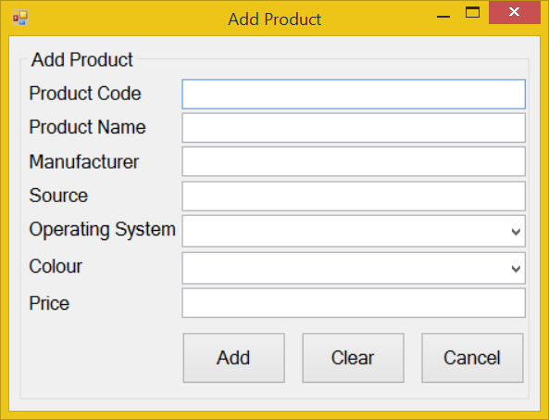

|  |  |  |  |  |  |
| --- | --- | --- | --- | --- | --- |
| **Screen** | Add products | | | | |
| **Description** | | Allow Administrator and Managers Account to add new products. | | | |
| **Screen Access** | | Users click on the button **Add Product -> Add New** | | | |
| **Screen Content** | | | | | |
| **Item** | | **Type** | **Data** | | **Description** |
| Product Code | | Text field – Alpha numeric (5) | Inserted into PRODUCT.CODE | | This field is mandatory. |
| Product Name | | Text field – String (45) | Inserted into PRODUCT.NAME | | This field is mandatory. |
| Manufacturer | | Text field – String (45) | Inserted into PRODUCT.MANU | | This field is mandatory. |
| Source | | Text field – String (45) | Inserted into PRODUCT.SOURCE | |  |
| Operating System | | Dropdown list – String (45) | Inserted into PRODUCT.OS | | This field is mandatory.  User choose the OS from available item in the dropdown list, if there’re any OS that not exist in the list, user can choose “Other”. |
| Colour | | Dropdown list – String (45) | Inserted into PRODUCT.COLOUR | | User choose the Colour from available item in the dropdown list, if there’re any Colour that not exist in the list, user can choose “Other”. |
| Price | | Text field – Number (45) | Inserted into PRODUCT.PRICE | | This field is mandatory. |
| Clear | | Button |  | | Clear all inputted data. |
| Add | | Button |  | | Add inputted data into database |
| Cancel | | Button |  | | Cancel to add new and back to “List” screen. |
| **Screen Actions** | | | | | |
| **Action Name** | | **Description** | | **Success** | **Failure** |
| Add | | Inputted data will be saved into the DB. | | Back to the “Add Product” screen with new record on the table below (default list with all data).  When go back to the list from “Add Product” screen, the new record will be focused on. | Display message: “Database connection error.”  Display message “The product code is already exist in the system. Please enter a new product code.”  Display message:  “Product Code must be entered.”  Display message:  “Product Code must be in the format of alpha numeric”.  Display message:  “Product Name must be entered.”  Display message:  “Manufacturer must be entered”.  Display message:  “Price must be entered.”  Display message:  “Price must be a number”  Display message:  “Operating system must be chosen”. |
| Clear | | Clear inputted data. | | Display “Add New” screen with blank data. | Nothing. |
| Cancel | | Close “Add” screen. | | Return to the “Add product” screen (default list with all data). | Nothing. |

## Remove products

### Screen Design

#### Remove product:

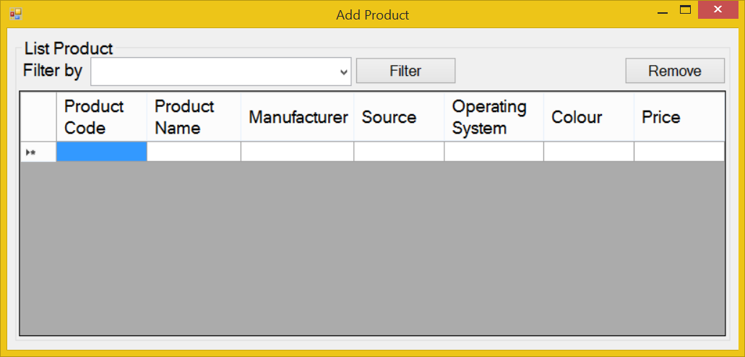

|  |  |  |  |  |  |  |
| --- | --- | --- | --- | --- | --- | --- |
| **Screen** | Remove product – Filter & Remove | | | | | |
| **Description** | | Display all products information base on the input field in the Filter | | | | |
| **Screen Access** | | Users run the program and click on **Remove products** | | | | |
| **Screen Content** | | | | | | |
| **Item** | | **Type** | **Data** | | **Description** | |
| Filter by | | Dropdown list - Alpha numeric (5) | Default: All.  Lookup from PRODUCT table by value inputted in the dropdown list. | | User can choose the filter item from dropdown list to filter the displayed result, such as product code, name, OS, etc. | |
| Filter | | Button |  | | Execute the filter | |
| Remove | | Button |  | | User click on it to remove a product chosen from the table below. | |
| **Screen Actions** | | | | | | |
| **Action Name** | | **Description** | | **Success** | | **Failure** |
| Filter | | List of all products will be ordered by PRODUCT.NAME.  When users choose any value in the above dropdown list and click Filter button then the system returns data of that product. | | Display general data of inputted Product code (data is selected from table PRODUCTS). | | Displays message “No data found.” in the Message Area. |
| Remove | | * If the user logged in is Administrative or Manager Account, then Product Code are displayed as links. * The user clicks on the item in the data grid view, then click on the “Remove” button to remove it. | | “Remove” pop up is displayed and ask user to confirm the command. | | Displays message “Cannot remove the product.” |

## Update

* Change the basic information of products (manufacturer, colour, source…)
* Change the product’s price.
* Add or remove special offer announcement.
* Update the product’s quantity.
* Update the product’s status.

### Screen design:

#### Update product - Filter:

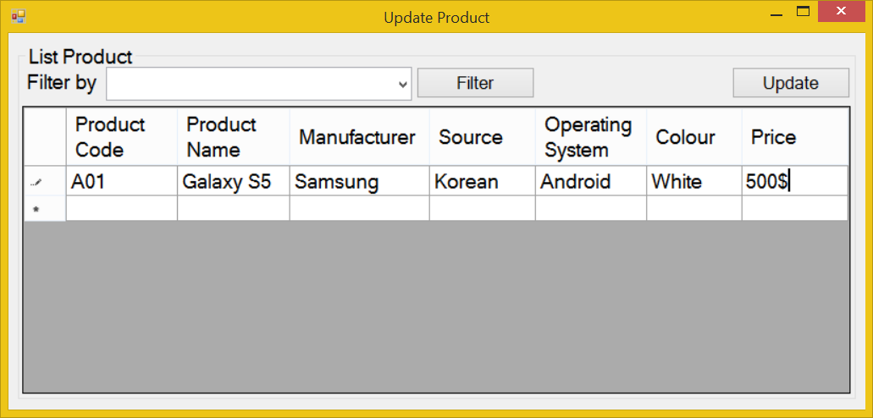

|  |  |  |  |  |  |  |
| --- | --- | --- | --- | --- | --- | --- |
| **Screen** | Update product – Filter | | | | | |
| **Description** | | Display all products information base on the input field in the Filter | | | | |
| **Screen Access** | | Users run the program and click on **Update products** | | | | |
| **Screen Content** | | | | | | |
| **Item** | | **Type** | **Data** | | **Description** | |
| Filter by | | Dropdown list - Alpha numeric (5) | Default: All.  Lookup from PRODUCT table by value inputted in the dropdown list. | | User can choose the filter item from dropdown list to filter the displayed result, such as product code, name, OS, etc. | |
| Filter | | Button |  | | Execute the filter | |
| Update | | Button |  | | User click on it to update a product chosen from the table below. | |
| **Screen Actions** | | | | | | |
| **Action Name** | | **Description** | | **Success** | | **Failure** |
| Filter | | List of all products will be ordered by PRODUCT.NAME.  When users choose any value in the above dropdown list and click Filter button then the system returns data of that product. | | Display general data of inputted Product code (data is selected from table PRODUCTS). | | Displays message “No data found.” in the Message Area. |
| Update | | * If the user logged in is Administrative or Manager Account, then Product Code are displayed as links. * The user clicks on the item in the data grid view, then click on the “Update” button to remove it. | | “Update Product” dialog will be displayed in order for user to edit the product’s information. | | Nothing. |

#### Update product - Update:

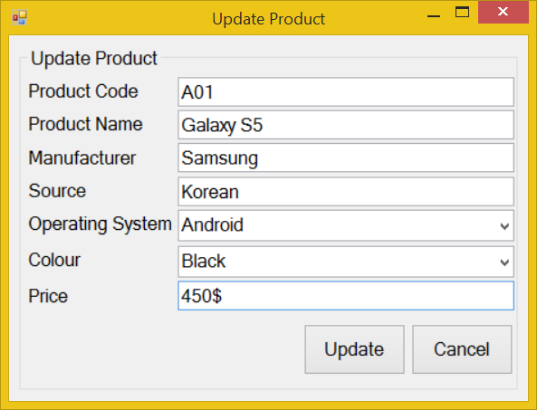

|  |  |  |  |  |  |
| --- | --- | --- | --- | --- | --- |
| **Screen** | Update products | | | | |
| **Description** | | Allow Administrator and Managers Account to update existing records. | | | |
| **Screen Access** | | Users run program and click on the button **Update Product -> Updates** | | | |
| **Screen Content** | | | | | |
| **Item** | | **Type** | **Data** | | **Description** |
| Product Code | | Text field – Alpha numeric (5) | This field is unique for each products.  Look up from PRODUCT.CODE | | This field is mandatory.  A sequence number that auto generated by database will be used as foreign key to join primary table and reference table.  So that, when we update value of any item in the main table, then that value can be referenced by other tables using foreign key. |
| Product Name | | Text field – String (45) | Look up from PRODUCT.NAME | | Display the name of products.  This field is mandatory. |
| Manufacturer | | Text field – String (45) | Look up from PRODUCT.MANU | | Display the name of manufacturer.  This field is mandatory. |
| Source | | Text field – String (45) | Look up from PRODUCT.SOURCE | | Display the source of manufacturer. |
| Operating System | | Text field – String (45) | Look up from PRODUCT.OS | | Display the OS of manufacturer.  This field is mandatory |
| Price | | Text field – Number (45) | Look up from PRODUCT.PRICE | | Price of product.  This field is mandatory |
| Colour | | Text field – String (45) | Look up from PRODUCT.COLOUR | | Colour of product. |
| Update | | Button |  | | Submit data. |
| Cancel | | Button |  | | Cancel update. |
| **Screen Actions** | | | | | |
| **Action Name** | | **Description** | | **Success** | **Failure** |
| Update | | Updated data will be saved into the DB. | | Back to the “Update Product” screen with updated record on the list.  If the user choose to update a product from the list of all products, then when go back to the list from update, the updated record will be focused on. | Display message “The selected record has been removed by someone.”  Display message “The selected record has been changed by another user! Please refresh to get the latest data for your update.”    Display message: “Database connection error.”  Display message:  “Product Code must be entered.”  Display message:  “Product Code must be in the format of alpha numeric”.  Display message “The product code is existed in the system. Please enter a new product code.”  Display message:  “Product Name must be entered.”  Display message:  “Manufacturer must be entered.”  Display message:  “Operating System must be chosen from the dropdown list.”  Display message:  “Price must be entered.” |
| Cancel | | Close “Update” screen and return to the list. | | Return to the “Update Product” screen. | Nothing. |